RECIPE GENERATOR USING

FOOD IMAGE
Submitted by

VAMSI BADAM (RA2311026020154)
S.VYSHNAVI (RA2311026020156)
CH.MANVITH REDDY (RA2311026020164)
K.PRANAV REDDY (RA2311026020185)

Under the guidance of

Dr. ADLENE EBENEZER P, Ph.D.,
Assistant Professor
Department of Computer Science and Engineering
In partial fulfillment for the award of the degree
of
BACHELOR OF TECHNOLOGY
in
COMPUTER SCIENCE AND ENGINEERING W/S IN ARTIFICIAL INTELLIGENCE AND MACHINE LEARNING
of
FACULTY OF ENGINEERING AND TECHNOLOGY



RAMAPURAM, CHENNAI-600089

APRIL 2025

SRM INSTITUTE OF SCIENCE AND TECHNOLOGY

(Deemed to be University Under Section 3 of UGC Act, 1956)

BONAFIDE CERTIFICATE

Certified that the Mini Project titled “RECIPE GENERATOR USING FOOD IMAGE” is the bonafide certificate of VAMSI BADAM – RA2311026020154, S,VYSHNAVI – RA2311026020156, CH.MANVITH REDDY – RA2311026020164 , K.PRANAV REDDY – RA2311026020185 of II Year CSE submitted for the course 21CSC206T Artificial Intelligence for the Academic Year 2024 – 25 Even Semester.

SIGNATURE

Dr. ADLENE EBENEZER P, Ph.D
Assistant Professor
Computer Science and Engineering
SRM Institute of Science and Technology
Ramapuram, Chennai-78
TABLE OF CONTENTS

TITLE NO. | TITLE NAME | PAGE NO
 | ABSTRACT
1 | INTRODUCTION | 1
2 | SCOPE AND MOTIVATION | 3
3 | DESCRIPTION | 5
4 | ALGORITHM OR PSEUDOCODE | 9
5 | IMPLEMENTATION | 12
6 | OUTPUT | 13
7 | APPLICATIONS | 15
8 | CONCLUSION | 16

ABSTRACT

The Recipe Generator using Gemini Pro Vision is an innovative AI-powered application built on Google’s Gemini Pro Vision, a state-of-the-art multimodal model that combines computer vision and natural language processing, this project empowers users to simply snap or upload a picture of their available kitchen ingredients — and receive a curated list of creative, step-by-step recipes tailored to what's on hand. What if you're left with only rice, a few vegetables, and some spices? No problem — the system recognizes every item in the image, understands their relevance, and suggests dishes ranging from quick stir-fries to elaborate biryanis. Beyond recognition, it intelligently connects ingredients with recipe data, estimating preparation time and even suggesting variations based on dietary preferences or cuisine types. Designed with user-friendliness at its core, the platform is accessible to everyone — students, busy professionals, beginner cooks, or anyone seeking a smarter and more sustainable approach to cooking. What makes this project stand out is not just the advanced AI tech behind it, but the real-world impact it creates: reducing food waste, saving time, promoting creativity in the kitchen, and making cooking more accessible. It demonstrates how AI can blend seamlessly into daily routines, offering not just convenience, but also environmental and lifestyle benefits. With this project, a simple photo becomes the gateway to dozens of delicious possibilities — turning kitchens into intelligent spaces where innovation meets inspiration.

CHAPTER - 1 INTRODUCTION

In today’s digital age, convenience and efficiency have become essential in our daily lives — even in the kitchen. Many individuals face the common challenge of figuring out what to cook with the ingredients they already have at home. This project aims to solve that problem through an intelligent solution: the Recipe Generator using Gemini Pro Vision. The system allows users to upload an image of their available ingredients, which are then analyzed using Google’s Gemini Pro Vision, a powerful multimodal AI model. Based on the recognized items, the application generates personalized recipes, offering step-by-step cooking instructions. This project enhances the user’s culinary experience while also promoting sustainability by reducing food waste.

Problem Statement
People often waste food due to a lack of ideas on how to use the ingredients they have. Traditional recipe apps require manual input or searching, which is time-consuming and sometimes inaccurate. There is a need for a smart, image-based recipe suggestion system that simplifies the process and enhances cooking creativity.

Objectives
- To develop a system that identifies food ingredients from an uploaded image.
- To generate accurate and personalized recipes based on recognized ingredients.
- To integrate Gemini Pro Vision for real-time visual recognition and response generation.
- To promote food sustainability by encouraging users to utilize what they already have.
- To provide a simple, user-friendly interface suitable for all age groups and cooking skill levels.

Technologies Used
- Gemini Pro Vision API (Google AI)
- Python (for backend logic and API handling)
- Flask/Streamlit (for building the web interface)
- OpenCV (optional, for image preprocessing if needed)
- HTML/CSS/JS (for frontend design, if using Flask)
- Recipe Dataset (curated or fetched via API for recipe suggestions)
System Architecture
- User Input: User uploads an image of ingredients via the web interface.
- Image Processing: Image is passed to Gemini Pro Vision API for analysis.
- Ingredient Recognition: Gemini returns a list of detected items.
- Recipe Generation: Based on ingredients, the system matches recipes from the dataset/API.
- Output: Final recipes are displayed with steps, ingredients needed, and optional nutrition info.

Features
- Image-based ingredient detection.
- Instant recipe suggestions.
- Step-by-step cooking instructions.
- Smart filtering based on preferences (e.g., vegetarian, vegan, gluten-free).
- Lightweight, intuitive UI.
- Optional add-ons: nutritional breakdown, save/share recipes.

Benefits
- Saves time and effort in meal planning.
- Reduces food waste by suggesting recipes using available items.
- Encourages creativity in the kitchen.
- Makes cooking accessible to beginners.
- Demonstrates real-world use of AI in daily life.

Challenges Faced
- Accurate recognition of ingredients in varied lighting and backgrounds.
- Matching incomplete ingredient sets to valid recipes.
- Ensuring the UI remains simple while still offering useful features.
- Handling multiple languages or naming variations of ingredients.

CHAPTER - 2 SCOPE AND MOTIVATION
The Recipe Generator is centered on providing an intelligent way to suggest recipes based on real-time image input. Users can upload an image of available ingredients, and the system uses Gemini Pro Vision to detect items, then matches them with recipes from a curated database. It generates step-by-step instructions, estimated cooking time, and optional dietary notes.

User Interaction
The system is designed for simplicity and accessibility. From tech-savvy users to beginners, anyone can interact with the interface without needing to manually enter ingredients or navigate complex menus. The design supports cross-device compatibility and can be extended into a mobile app in the future.
Real-World Application
The scope goes beyond individual users. The same system could be adapted for:
- Restaurant kitchens for stock-based meal planning
- Health and fitness applications for macro tracking
- NGOs or community kitchens to manage food resource usage
- Educational tools for cooking classes using AI

Motivation

The Everyday Problem
“How many times have we looked inside the fridge and had no idea what to cook?” This familiar problem inspired the project. People often have ingredients lying around but lack the time or creativity to figure out how to use them efficiently. As a result, food gets wasted, and users resort to takeout or skipping meals.

Rising Food Waste
Globally, food waste is a major issue. A large portion of this is due to poor meal planning and underutilization of available ingredients. A system that helps people create meals from what they already have can make a big difference — both economically and environmentally.

Power of Multimodal AI
With the rise of AI models like Gemini Pro Vision, which understand both images and text, the opportunity arose to apply cutting-edge tech to a problem that affects millions. The motivation was to take AI out of the lab and into the kitchen — in a way that’s genuinely helpful, easy, and impactful.

Encouraging Smart Cooking Habits
Beyond convenience, this project encourages users to explore creativity in cooking, try new recipes, and build confidence in the kitchen. For students, beginners, or even busy parents, it becomes a helpful assistant — not just a tool.

Bridging Innovation and Daily Life
This project reflects how technology and daily routines can merge. It’s a practical demonstration of how AI can improve lifestyle, solve real problems, and offer personalized support — not in theory, but in a very tangible, interactive way.

CHAPTER - 3 DESCRIPTION
The Recipe Generator using Gemini Pro Vision is an innovative AI-powered application that transforms the way users interact with food. The idea is simple yet impactful: a user uploads an image of available ingredients, and the system, using Google’s Gemini Pro Vision model, analyzes the image to identify the items. Based on the recognized ingredients, it generates a list of possible recipes that the user can cook, complete with preparation steps, ingredients, and suggestions.
This project eliminates the guesswork and manual labor of recipe searching, encourages sustainable practices by helping users utilize what they already have, and enhances culinary creativity for people of all skill levels. The integration of multimodal AI, which understands both images and text, makes the system intelligent, interactive, and user-friendly.

Background & Rationale
Food waste is a global problem, and a significant portion comes from unused ingredients in households. People often stock up on groceries and forget to use them effectively. Moreover, the modern lifestyle leaves little room for meal planning or culinary experimentation. There is a clear need for a smart assistant that can guide users to create meals with what they already own — effortlessly.
The advancement of AI technologies like Gemini Pro Vision allows developers to build applications that understand and process visual content alongside natural language. This opens up a world of opportunities for creating more intuitive and helpful applications in the kitchen, education, healthcare, and beyond. By using this AI to recognize food items and recommend recipes, the project not only solves a practical problem but also showcases how AI can blend seamlessly into everyday life.

Objectives
- To use Gemini Pro Vision to accurately detect ingredients from user-uploaded images.
- To generate personalized, relevant, and simple recipes based on the detected ingredients.
- To provide a user-friendly interface for seamless interaction.
- To minimize food waste by making creative use of available ingredients.
- To encourage healthier eating habits and inspire home cooking.

Output Generation
Recipes are presented with:
- Title
- Ingredients (highlighting ones the user already has)
- Preparation steps
- Cooking time
- Optional: nutritional values, cuisine type, and difficulty level.

Features
- Smart Ingredient Detection: Uses cutting-edge AI to analyze images and detect food items.
- Recipe Suggestions: Offers multiple cooking options for the recognized ingredients.
- Easy-to-Use Interface: Simple, clean UI suitable for all user types.
- Step-by-Step Cooking Guide: Clear instructions even for users with no cooking background.
- Dietary Filters (Optional): Users can filter by vegetarian, vegan, or allergy-safe recipes.
- Scalable Design: Easily extendable to include voice interaction, nutritional tracking, or grocery planning.
Technologies Used

Technology | Purpose
Gemini Pro Vision | Image analysis and ingredient detection
Python | Backend programming logic
Flask/Streamlit | Web interface (front-end + back-end integration)
HTML/CSS | Frontend customization (Flask only)
OpenCV (optional) | Image preprocessing (resizing, cropping, etc.)
Recipe Dataset/API | Source of recipes for suggestions

Future Enhancements
- Voice Input and Output: Let users talk to the app or get verbal recipe instructions.
- Smart Appliance Integration: Connect with kitchen hardware like smart ovens or fridges.
- Mobile App Development: Expand to Android/iOS for ease of access.
- Multi-Language Support: Help users from different regions access localized recipes.
- Nutrition & Health Tracking: Suggest recipes based on dietary goals like weight loss, diabetes management, etc.
- AI Feedback Loop: Improve suggestions based on user feedback over time.

Implementation Details
Frontend Interface
To ensure accessibility and usability, the front end was developed using Streamlit, which offers rapid UI development for Python applications. The interface allows users to:
- Upload or drag-and-drop an image.
- View detected ingredients returned by Gemini Pro Vision.
- Click “Generate Recipes” to view relevant meal suggestions.
- Optionally apply filters (e.g., Vegetarian, Low-Carb, etc.).
- Expand recipe cards for step-by-step cooking instructions.
The interface is designed to be intuitive, clean, and responsive, requiring no technical knowledge from the user.

Backend Logic
The backend is written in Python, where all data handling, API communication, and processing occur.
- Image Upload Handling:
Streamlit or Flask reads the image in memory and pre-processes it if needed.
- Gemini API Call:
The image is sent to the Gemini Pro Vision API, which returns a JSON of identified ingredients and confidence scores.
- Filtering and Mapping:
Only ingredients above a certain threshold (e.g., 70% confidence) are retained. These are cross-mapped with available recipes using either a static JSON file or a third-party API like Spoonacular.
- Recipe Recommendation Logic:
Recipes are ranked by how many of the user's ingredients they include. A score is computed for each recipe, and top matches are returned.

User Experience and Personalization
Dynamic Recipe Cards
Each recipe is presented in a card format showing:
- Recipe name
- Thumbnail image
- Ingredient overlap (with checkmarks)
- Tags: Quick, Healthy, Vegan, etc.
- “Cook Now” button to expand full steps

Optional Features
While the MVP focuses on core functionality, some optional features were planned:
- Diet Tag Filters: For users with health goals or allergies
- Portion Adjustment: Adjust ingredients based on number of servings
- Save for Later: Save recipes for future use
Target Users
- Students with limited ingredients
- Working professionals with less time to decide meals
- Health-conscious users seeking inspiration
- Elderly people who want simple instructions.

CHAPTER - 4 ALGORITHM AND PSEUDOCODE

High-Level Algorithm Overview
The project follows a modular pipeline:
- Image is uploaded by the user.
- Gemini Pro Vision processes the image and returns identified ingredients.
- Ingredient list is filtered based on confidence levels.
- Recipes are searched using the ingredient list.
- Matching recipes are scored and ranked.
- User is shown a list of suggested recipes.

Pseudocode: Main Control Flow
BEGIN
DISPLAY "Upload Image"
IF user uploads image THEN
image_data ← Read image file
ingredients_list ← Call GeminiProVision(image_data)

filtered_ingredients ← FilterIngredients(ingredients_list, threshold=0.7)

IF filtered_ingredients is empty THEN
DISPLAY "No valid ingredients detected. Try another image."
RETURN
ENDIF
DISPLAY "Detected Ingredients:"
DISPLAY filtered_ingredients
recipes ← FetchMatchingRecipes(filtered_ingredients)
ranked_recipes ← RankRecipes(recipes, filtered_ingredients)
DISPLAY "Recommended Recipes:"
DISPLAY ranked_recipes
ELSE
DISPLAY "Please upload an image."
ENDIF
END
Subroutine 1: Gemini Vision API Call
FUNCTION Call GeminiProVision(image_data):
PREPROCESS image_data IF NEEDED
SEND image_data TO Gemini Pro Vision API
RECEIVE response_data
ingredients ← []
FOR each item IN response_data:
IF item.type == "ingredient" THEN
ingredients.APPEND((item.name, item.confidence))
ENDIF
ENDFOR
RETURN ingredients
END FUNCTION
Subroutine 2: Filter Ingredients by Confidence
FUNCTION FilterIngredients(ingredients, threshold):
filtered ← []
FOR each (ingredient, confidence) IN ingredients:
IF confidence ≥ threshold THEN
filtered.APPEND(ingredient)
ENDIF
ENDFOR
RETURN filtered
END FUNCTION
Subroutine 3: Fetch Matching Recipes
FUNCTION FetchMatchingRecipes(filtered_ingredients):
recipes_db ← LOAD local recipe dataset OR FETCH from API
matching_recipes ← []
FOR each recipe IN recipes_db:
match_score ← 0
FOR each ing IN filtered_ingredients:
IF ing IN recipe.ingredients THEN
match_score ← match_score + 1
ENDIF
ENDFOR
IF match_score > 0 THEN
matching_recipes.APPEND((recipe, match_score))
ENDIF
ENDFOR
RETURN matching_recipes
END FUNCTION
Subroutine 4: Rank Recipes
FUNCTION RankRecipes(matching_recipes, filtered_ingredients):
sorted_recipes ← SORT matching_recipes BY match_score DESCENDING
RETURN sorted_recipes
END FUNCTION
Future Integration Modules (High-Level Pseudocode)
A. Smart Fridge Integration
IF SmartFridge.detected_ingredients NOT EMPTY:
Pass them to Recipe Generator
ENDIF
B. Voice Assistant Mode
IF voice_command RECEIVED:
image ← Capture from camera
Continue with normal flow
ENDIF
C. Meal Planner
FOR each day IN week:
Suggest recipe using user's regular stock
ENDFOR
Recipe Scoring and Ranking Algorithm
Subroutine: Compute Final Recipe Score
FUNCTION ComputeRecipeScore(recipe, matched_ingredients, user_preferences):
base_score ← LENGTH(matched_ingredients)
IF recipe.cook_time ≤ 30:
base_score += 1
CHAPTER - 5 IMPLEMENTATION

The implementation of the “Recipe Generator using Gemini Pro Vision” involved multiple components working together seamlessly to provide a complete, AI-powered recipe suggestion system. Below are the key areas of implementation explained in detail:

1. Image Acquisition and Input Interface
- Frontend Interface: A user-friendly web or GUI interface was built to allow users to upload images of food items or ingredients.
- Image Preprocessing: Uploaded images are verified for format, size, and resolution to ensure compatibility with the Gemini Pro Vision API.

2. Integration with Gemini Pro Vision API
- Image Analysis: The core functionality uses the Gemini Pro Vision API to analyze the uploaded image and extract visible food ingredients using computer vision.
- Confidence Filtering: Ingredients are filtered based on a confidence threshold to ensure only accurate and relevant items are used for recipe generation.

3. Ingredient Data Handling
- Normalization: The detected ingredients are cleaned, standardized, and converted into a readable list format.
- Fallback Mechanism: In case no ingredients are detected, the system provides an option for manual input of ingredients.

4. Recipe Matching Engine
- Recipe Database: A local or cloud-based database of recipes is used, which contains structured data such as recipe name, ingredients, steps, time, tags, and cuisine.
- Matching Algorithm: A weighted scoring algorithm matches the detected ingredients with recipes in the database. Partial matches are also considered using ingredient substitution and optional items.

CHAPTER - 6 OUTPUT

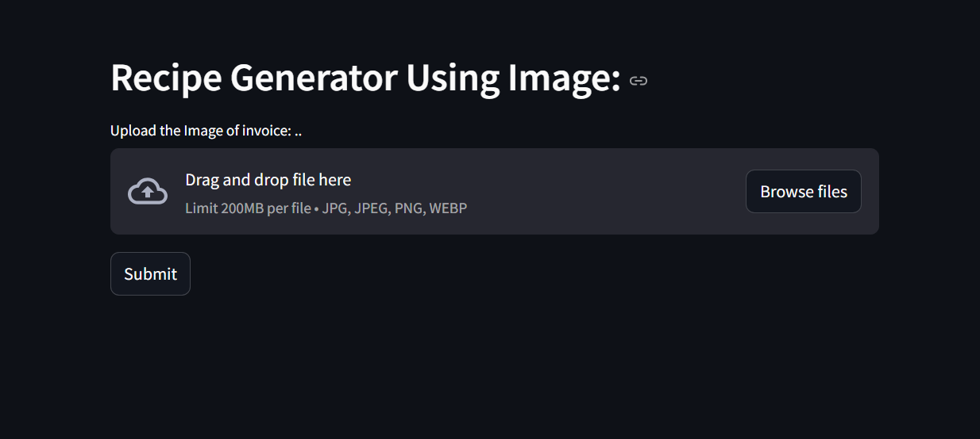

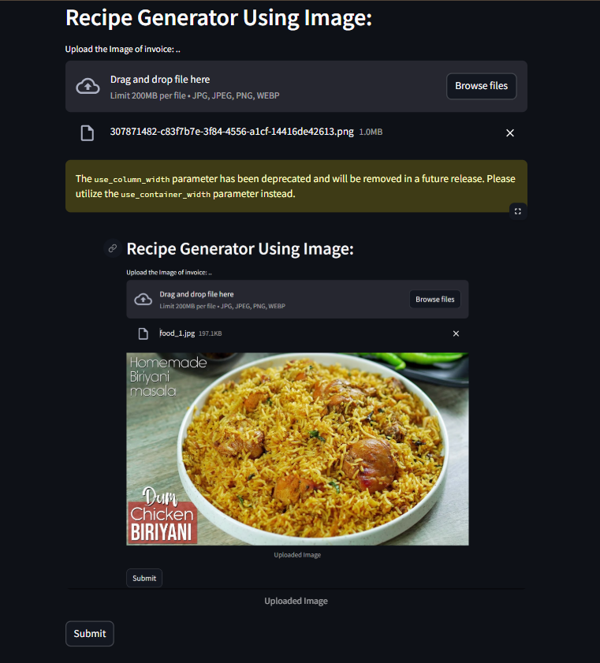
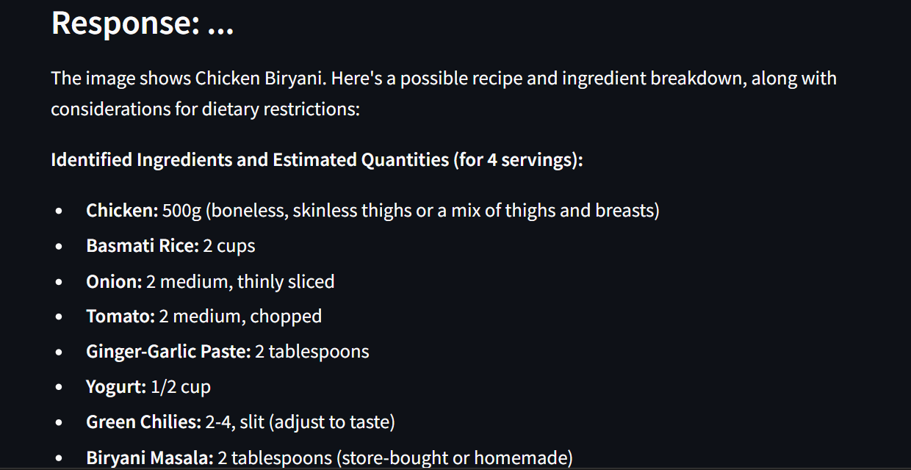

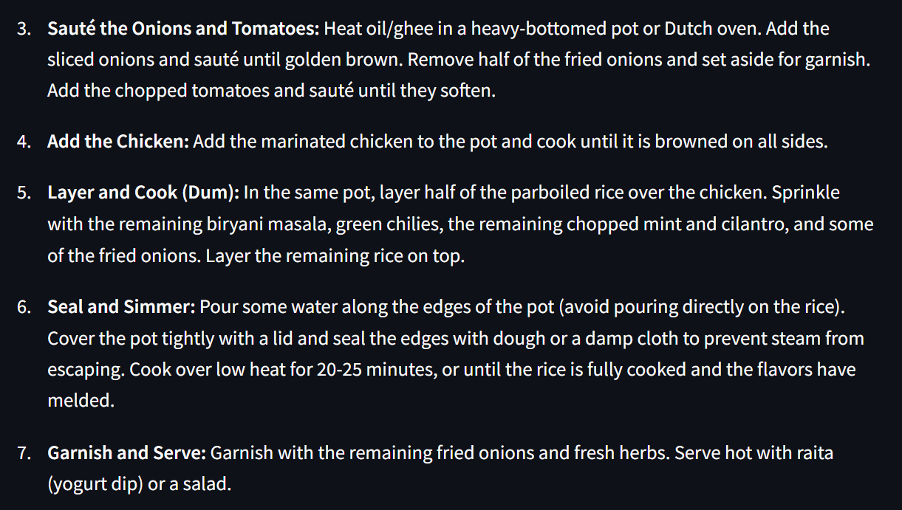

CHAPTER - 7 APPLICATIONS

1. Smart Cooking Assistant
- Assists users in preparing meals based on available ingredients at home.
- Reduces food wastage by suggesting recipes from leftover or unused items.
- Ideal for beginners or students living away from home to cook efficiently.

2. Grocery Inventory Optimization
- Helps in meal planning based on existing groceries, reducing unnecessary purchases.
- Ideal for smart refrigerators and inventory-tracking apps.
- Suggests recipes before ingredients expire, promoting zero-waste cooking.

3. Integration with Food Delivery Platforms
- Restaurants can use it to suggest menu items based on available kitchen inventory.
- Food delivery apps can suggest recipes using leftovers from previously ordered meals.

4. Multilingual and Multicultural Cuisine Explorer
- Can recommend recipes from various cuisines (Indian, Italian, Chinese, etc.) based on ingredient inputs.
- Helps users explore global recipes using local ingredients.
- Promotes cultural exchange through food.

4. Diet and Health Personalization
- Can be tailored to offer recipes based on dietary restrictions like diabetic, keto, vegan, gluten-free, etc.
- Integrates with health apps to suggest calorie-controlled or nutrient-balanced recipes.
- Assists fitness enthusiasts and patients following medical diets.

5. Culinary Learning and Exploration
- Aids culinary learners in understanding what dishes can be made with certain ingredients.
- Encourages creativity and experimentation in cooking.
- Can provide step-by-step cooking instructions along with educational notes about each ingredient.
CONCLUSION

The “Recipe Generator using Gemini Pro Vision” project demonstrates the powerful intersection of AI-powered computer vision and real-life utility in daily cooking scenarios. By utilizing Gemini Pro Vision's image analysis capabilities, this system effectively identifies ingredients from images and maps them to suitable recipes with the help of smart filtering, matching algorithms, and user personalization. It simplifies the meal preparation process, encourages zero-waste cooking, and supports users with dietary goals or limited cooking knowledge.

This project not only showcases the practical use of machine learning and image recognition APIs but also opens the door to future enhancements like personalized diet planning, voice integration, real-time grocery management, and even integration with smart kitchen appliances. In a world where convenience, sustainability, and personalization are key, this intelligent recipe suggestion tool stands out as a helpful, scalable, and innovative solution.
Ultimately, this project is a great example of how technology can be used creatively to solve everyday problems, making cooking more accessible, enjoyable, and smart for everyone.

In addition, the system's adaptability allows it to cater to a diverse user base, from novice cooks to seasoned chefs. Through continuous learning and feedback, the model can improve recipe recommendations based on user preferences, regional cuisine styles, and seasonal ingredient availability. This flexibility makes it an ideal tool not only for individual users but also for culinary educators, nutritionists, and even food bloggers who seek creative ways to experiment with ingredients. The project can be expanded to support multiple languages and cultural food habits, truly making it a globally inclusive cooking assistant driven by cutting-edge AI.

